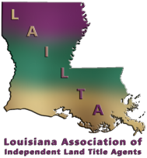

AGENDA
2023 Annual Spring Conference
April 2nd & 3rd, 2023

Sunday, April 2nd, Icebreaker 6:00 pm – 10:00 pm. The Icebreaker will be held at the TAP ROOM, LOCATED AT 201 Settlers Trace, #4001.
Sponsored by Stewart Title

Monday, April 3rd,
8:30 – 9:15 Breakfast Sponsored by: Westcor Land Title Insurance Company

9:15 – 10:15 Speaker The Good, and the Bad And the Ugly – An Outlook for the Economy and Real Estate
Ted Jones, PhD Chief Economist with Stewart Title
10:15 – 11:15 Speaker UDAAPs & CFPB: Can Independents Be Saved?
Todd Ewing, Federal Title & Escrow Company

11:15- 11:30 Break Sponsored by: First American Title Insurance, Security Title
Guarantee Corporation, FNF Family of Companies & Old
Republic

11:30 – 12:30 Speaker BANKRUPTCY AND Real Estate: “The Title Company Must Be Liable Because No One Else Has Money”
Gene Hastings, Bayou DeSiard Title Company, LLC

Dinner on your own or with your favorite underwriter and then head on over to “The Ruins” at 8:00 pm for a good time with the band “Shot-Gun Lillie”!

